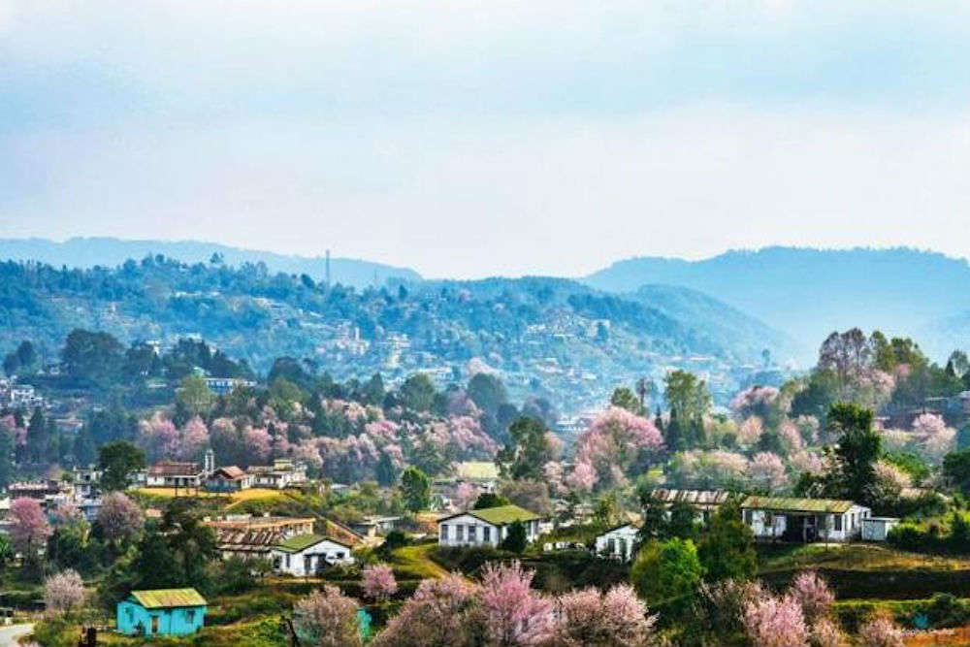
STAKEHOLDER CONSULTATION PROCEEDINGS

DEVELOPING DISASTER RESILIENCE ACTION PLAN SHILLONG CITY, MEGHALAYA

15th December 2020

Supported by:
National Mission on Himalayan Studies (NMHS),
under
Ministry of Environment, Forest and Climate Change, Government of India (MoEFCC, GoI)

Prepared by:

Integrated Research and Action for Development (IRADe)

© 2020 Integrated Research and Action for Development (IRADe)

“Developing Disaster Resilience Action Plan through GIS and Prioritizing the Actions for Natural Disaster Risk Reduction for Urban Agglomerations of Shillong and Gangtok”
Supported by: National Mission on Himalayan Studies (NMHS), under Ministry of Environment, Forest and Climate Change, Government of India (MoEFCC, GoI)

Disclaimer

All rights reserved. No part of this publication may be reproduced or transmitted in any form or by any means, electronic or mechanical, including photocopy, recording or any information storage and retrieval system, without permission in writing from IRADe. The presentation of material in this publication which appear herein does not imply the expression of any opinion on the part of IRADe concerning the legal status of any country, state or city or the delineation of their frontiers or boundaries.

Acknowledgement

We would like to thank everyone who has contributed to the Stakeholder Consultation on Developing Disaster Resilience for Shillong city, Meghalaya, under the Project ‘Developing Disaster Resilience Action plan through GIS and prioritising actions for Natural Disaster Risk Reduction in Urban Agglomerations of Shillong & Gangtok’ supported by Ministry of Environment, Forest and Climate Change Government of India (MoEFCC, GoI). Under the National Mission on Himalayan Studies (NMHS) programme). We thank Meghalaya State Disaster Management Authority (MSDMA) for their support and inputs for the stakeholder workshop. We are thankful to our partner organizations North Eastern Space Application Centre (NESAC) and GB Pant National Institute of Himalayan Environment – Sikkim Regional Centre (NIHE-SRC).

We are particularly thankful to Kum. Isawanda Laloo, IAS, Deputy Commissioner, East Khasi Hills District, Shillong and Smt. I Mawlong, Executive Director, Meghalaya State Disaster Management Authority (MSDMA), Dr. P L N Raju, Director, NESAC, Prof. Ajit Tyagi, Senior Advisor, IRADe for their guidance, support and participation.

We are thankful to Prof. Jyoti Parikh, Executive Director, IRADe for her valuable support and guidance throughout the project.

The consultation could not have been taken place without the support of Shillong Municipal Board (SMB), Geological Survey of India (GSI)-Shillong, India Meteorological Department (IMD)-Meghalaya and Meghalaya State Disaster Management Authority (MSDMA)

IRADe extends its gratitude to all the speakers, panellists and participants of the Consultation for their time, input and expert advice in developing the Disaster Resilience Action Plan for Shillong. Last but not the least we would like to thank IRADe team of researchers- Dr. Mohit Kumar, Ms Moumita Shaw, Research Analyst, Ms Ananya Bhatia, Ms Yashi Sharma supported in contributing to the workshop and its proceedings.

Mr Rohit Magotra Prof. Ajit Tyagi
Deputy Director, IRADe Senior Advisor, IRADe

Project & Workshop Partners

Project Partners
National Mission on Himalayan Studies, NMHS

Ministry of Environment, Forest & Climate Change, MoEFCC, GoI
 | Integrated Research & Action for Development, IRADe
 | North Eastern Space Application Centre, NESAC
 | GB Pant National Institute of Himalayan Environment (NHE)
Supporting/ CollaboratingOrganization
 | Meghalaya State Disaster Management Authority
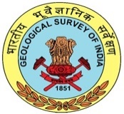 | Geological Survey of India (GSI), NE-Meghalaya
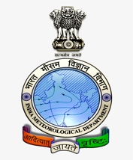 | India Meteorological Department (IMD), Meghalaya
 | Shillong Municipal Board, SMB

Table of Content

1. Introduction 1
2. Background 2
2.1 Need for the stakeholder’s workshop 3
3. Developing Disaster Resilience Action Plan, Shillong 4
Special Remarks 4
Address by Special Guest 4
Address by the Chief Guest 6
Session on Disaster Resilience Action Plan: Methodology & Project Outputs 6
Panel Discussion 6
Recommendations & Strategies 7
4. Screenshot of the Stakeholders Consultation 10
Annexure 11
Annexure 1: Workshop Agenda 11
Annexure 2: List of Participants 13
About the Project 16
About CoE 16
About IRADe 16

Introduction
India is geographically located in the high disaster-prone region and has been continuously impacted by natural disasters like floods, cyclones, landslides, earthquakes, heatwaves and Tsunami. 27 out of 35 states and union territories are prone to these types of hazards. Over the past thirty years, earthquakes have accounted for 34.8% of total deaths by natural disasters. During 1980-2010, India has experienced nearly 431 natural disasters killing around 0.00014 billion people and affecting around 150 million people, with an estimated economic loss of USD 48.06 billion., .

Global Climate Risk Index report 2019, had stated India as the 14th most vulnerable country in the world due to extreme weather-related events, with around 2,736 lives lost in 2017 due to disasters. The Global Climate Risk Index report 2020, ranks India 5th in 2018 in the global vulnerability ladder, with a highest recorded number of fatalities due to climate change and the second-highest monetary losses from its impact in 2018. India’s high rank is due to severe rainfalls, followed by massive flooding and landslides that killed over 1000 people.

Indian Himalayan region covers 16% of India’s total geographical area, spread over 12 states. Himalayan Region (IHR) is considered to be vulnerable to a variety of natural disasters like earthquakes, floods, landslides and forest fires etc. According to the United Nations-affiliated organization and Planning Commission, the Himalayan region, on an average is hit by 76 disasters, killing 36,000 people and affecting 178 million people every year. Nepal-based International Centre for Integrated Mountain Development claimed that India’s Himalayan region was hit by 532 natural disasters between 1990-2012¹⁰.

Shillong, capital city of Meghalaya, 2nd largest city in North-East Himalayan Region of India. The city is prone to the consequences of climate change because of its geo-ecological fragility, the eastern Himalayan landscape, its trans-boundary river basins and its inherent socio-economic instabilities. Shillong city is vulnerable to both natural hazards such as landslides, heavy rainfall, floods etc. and man -made disasters such as road accidents, fires, water scarcity due to rapid growth of urbanization and improper and uncontrolled construction. It is forecasted that for East Khasi hills district (Shillong) the temperature increase is expected to be 1.6-1.7°C by 2050 (Meghalaya State Action Plan on Climate Change, 2015).

Background

North-East (NE) India is vulnerable to natural and man-made disasters because of its location in the Eastern Himalayan periphery, its fragile geo-environmental setting and economic underdevelopment. The vulnerability of the entire NE region due to earthquake, floods and high wind velocity is very high. The seven states of NE region lie in Seismic Zone V, and Meghalaya lies in Zone IV which poses serious threats to life and property
Physical risks and vulnerabilities posed by disasters in the Himalayan cities are often accompanied by a lack of necessary resources – financial, human and institutional – as well as access to relevant scientific information to cope with them. It is virtually impossible to prevent the occurrence of natural hazards, but it is possible to contain and prevent them from turning into disasters. It is imperative to concentrate on minimizing and mitigating the magnitude of the damaging effects of disasters by undertaking plausible disaster risk reduction measures through better scientific tools and knowledge and taking steps to build the resilience of the citizens, especially vulnerable communities. Thus, there is a need for a systematic review to collect evidence related to the impact of urbanization on disaster risk and vulnerability to natural disasters in the Indian Himalayan region.
Under the project Developing Disaster Resilience Action plan through GIS and prioritising actions for Natural Disaster Risk Reduction in Urban Agglomerations of Shillong & Gangtok supported by National Mission on Himalayan Studies (NMHS), under Ministry of Environment, Forest and Climate Change Government of India (MoEFCC, GoI), IRADe with partner organizations North Eastern Space Application Centre (NESAC) and GB Pant National Institute of Himalayan Environment (GBPNIHESD-SRC) aims to develop Disaster Resilience Action Plan for Shillong city.
The Objectives of the project are:
- To develop maps at the scale of 1:4000 and map the hazard/disaster wise vulnerable zones of the Gangtok and Shillong urban agglomerations
- To identify and map critical infrastructure at risk through ground surveys – telecommunication, emergency operation centres, shelter, slums, hospitals, schools etc. on maps of 1:4000.
- To develop a disaster resilience action plan for the identified cities and prioritize actions for disaster risk reduction through multi-stakeholder consultations involving citizens, government, public and private sector.
- To spread awareness and capacity building of citizens, city, district and state authorities on disaster resilience of the North East Region Cities.

Following Outputs are envisaged from the project:
- Land use/land cover maps of NE cities at cadastral scale 1:4000
- Disaster wise Vulnerable zone maps of identified cities
- Vulnerability assessment of selected NE cities to natural disasters
- Critical infrastructure risk mapping of identified cities
- Disaster resilience plans for the two NE cities
- Capacity building of the city, district and state authorities on disaster resilience.

Need for the stakeholder’s workshop

Integrated Research and Action for Development (IRADe) in collaboration with Meghalaya State Disaster Management Authority (MSDMA) organized a Stakeholders’ workshop on “Developing Disaster Resilience Action Plan, Shillong city, Meghalaya”.
As a part of the Project’s broad objectives, it was intended to deliberate the development of a disaster resilience action plan for the city with a diverse set of stakeholders through this workshop. The objectives of the workshop included:
- Discussion on the Key Strategies adapted to draft Disaster Resilience Action Plan
- Hazard and Risk Mapping at the scale of 1:4000, while mapping the hazard/disaster wise vulnerable zones of the Shillong urban agglomerations.
- Study of the Impact of Urbanization

Developing Disaster Resilience Action Plan, Shillong
Integrated Research and Action for Development (IRADe) in collaboration with Meghalaya State Disaster Management Authority (MSDMA) organised a Stakeholders workshop on “Developing Disaster Resilience Action Plan for Shillong city, Meghalaya”, on 15th December, 2020. The workshop was conducted to share the results and findings of the project on Developing Disaster Resilience Action Plan for Shillong which is led by IRADe, in association with North Eastern Space Applications Centre (NESAC) and G B Pant National Institute of Himalayan Environment (GBPNIHESD-SRC).

The workshop was inaugurated by Special Guests Ms I Mawlong, Executive Director, Meghalaya State Disaster Management Authority (MSDMA) and Ms IsawandaLaloo, IAS, Deputy Commissioner, East Khasi Hills District, Meghalaya

Special Remarks

Prof. Jyoti K Parikh, Executive Director IRADe, in her welcome address shared work done by IRADe in Indian Himalayan Region and on the importance of disaster resilience in the vulnerable North Eastern Himalayan cities. She emphasized on the use of Remote Sensing and GIS to develop action plans which help in emergencies and disasters. She explained that the ongoing Action Plan for Shillong focuses on developing ward level resilience to natural disasters like floods, landslides and earthquakes, and can be a good case study for other Himalayan cities.
Prof Jyoti K Parikh,
Executive Director IRADe

Address by Special Guest
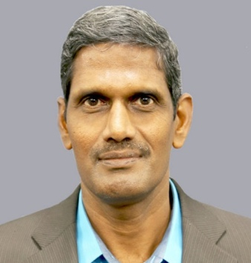
Dr. P L N Raju, Director, NESAC gave special remarks and emphasized on the importance of a digital database for the project so that this could be used and updated by the government, State disaster Management Board and Municipal Boards. The currency of data is important wherein the database created is shared and help in the capacity building of several user departments in Meghalaya state. He emphasized on the need for training and capacity building of the city and state departments.
Dr. P L N Raju,
Director,NESAC

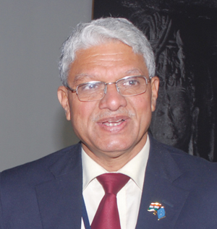
Prof. Ajit Tyagi,
Senior Advisor,IRADe
Prof. Ajit Tyagi, Senior advisor, IRADe, in his remarks emphasised on the importance of this pioneer project which would set a benchmark for other Disaster Resilience Action Plans as this is the first time such High-resolution data on 1:4000 scale for Ward level is being used for the Disaster Resilience Action Plans.

Smt. I Mawlong, Executive Director, Meghalaya State Disaster Management Authority (MSDMA) gave a brief introduction on the disasters in Meghalaya. She mentioned the Sendai Framework for Disaster Risk Reduction 2015-2030, which provides concrete actions to protect development gains from the risk of disaster. She also mentioned that there is a need for capacity building for resilience. She also stressed on the ten essentials for masking cities resilient as stated by UNDRR:
Smt. I Mawlong, Executive Director, MSDMA

1. Institutional and administrative frameworks;
2. Financing and Resources;
3. Multi-Hazard Risk Assessment – Know Your Risk;
4. Infrastructure Protection, Upgrading and Resilience;
5. Protect Vital Facilities: Education and Health, (Food and Water) supplies;
6. Building Regulations and Land Use Planning;
7. Training, Education and Public Awareness;
8. Environmental Protection and Strengthening of Ecosystems;
9. Effective Preparedness, Early Warning and Response;
10. Recovery and Rebuilding Communities.

Address by the Chief Guest
Ms. Isawanda Laloo, IAS, Deputy Commissioner, East Khasi Hills District, Meghalaya) explained that Shillong is a centre for commercial, administrative, tourist and business activities and due to its regional settings in terms of topography and haphazard urban development, it is more vulnerable to several natural and manmade disasters. Detailed plans are required to assess the requirements during hazards. She shared insights into the City Disaster Management Plan, building a culture of safety in the city through UNDP-USAID project in collaboration with SDMA, influencing and enhancing community participation in climate change through a series of workshops and capacity building among city stakeholders. She also pointed out that major institution like hospitals, schools, NGOs and likewise have submitted their individual disaster mitigation plans and workshops were also conducted to support such initiatives.
Ms Isawanda Laloo, IAS, Deputy Commissioner, DDMA

Session on Disaster Resilience Action Plan: Methodology & Project Outputs

A detailed presentation on Hazard and Risk mapping of Shillong Urban Agglomeration in the current project was given by Ms. Nikita Lahiri, Research Fellow, NESAC. Mr. Rohit Magotra, Deputy Director IRADe, and Ms. Moumita Shaw, Research Analyst, IRADe shared the highlights of the Disaster Resilience Action Plan for Shillong.

Panel Discussion

The esteemed panellists for the workshop also included Dr. Nagaraja Ravoori, Former Deputy Director, NRSC, Prof. Devesh Walia, Professor, NEHU, Mr. D. P. Dangwal, Suptdg. Geologist, GSI-NER, Shillong, Dr. Saurabh Baruah, Chief Scientist, CSIR Northeast Institute of Science and Technology, Jorhat, Assam.

Recommendations & Strategies

Key Points | Recommendations/ Comments | Strategies
Construction/ Building Bye-laws | Buildings and structures (Govt., residential - commercial buildings exceeding 30 years of age needs to be audited | Point shall be included in the structural measures in Resilience Strategy
 | Land-use management, building use regulations, safety codes, preventive health care provisions and public education and take appropriate measures for long term mitigation strategies | This shall be included in the Long term measures for land-use land-cover mapping and structural planning
 | Regular re-visiting and updation of the data-base | Has been included in the short & medium -term measures
Vulnerability Assessment | Vulnerability mapping is only limited to the Shillong Municipal Board area | Hazard-risk mapping covers the Shillong Urban Agglomeration (174sqkm), however the socio-economic vulnerability is limited to the Shillong Municipal Board, as per the availability of the data and as most of the agglomeration area outside of municipal limits has scattered-population and records were not clearly available.  Agglomeration data can be incorporated on the availability from the ULB and Urban Development Department of Meghalaya  Clear demarcation shall be made the survey area and the mapping area
 | Economic Data is not included in the Socio-economic vulnerability assessment | Economic data has not been included as the analysis was based on the primary household survey on the assessment of the impact of urbanization on climate change  Slum Population, Women and children population vulnerability has been calculated, to indicate the vulnerability of the economically weaker and depended section of the city to hazards like landslide and urban floods.
Mapping | Image Quality : Higher resolution data is required , Higher resolution DEM is required to accurately map the areas affected by particular disasters and the impact of the same | Higher resolution AIRBUS World DEM Data is being acquired by NESAC from NRSC.
 | Flash Flood Mapping – watershed of streams and rivers are required to be mapped (river discharged by rivers) | The scope indicates Flood plain topography study, rather than hydro-dynamic data study, hence the methodology of flood susceptible mapping is followed.  This will be mentioned in the methodology of mapping
 | Landslide Mapping – all landslide events are not mapped | Updated data has been requested from GSI
 | Earthquake Mapping - lineament mapping has not been carried out properly, need to refer to seismic data, National Seismic Risk Mitigation Prog. IMD, and Seismological Observatory for Shillong area specific data | The same will be looked into on reframing the methodology and mapping earthquake susceptible areas.
 | Critical Infrastructure Mapping – Symbols and the protocols used needs to be defines | The symbols and protocols for mapping is used as per the guidelines of AMRUT (GoI)
Resilience Action Plan | Need to address capacities – capacity building, stakeholder mapping, capability mapping  Coordination plan for the various stakeholders,  SOPs for the implementation of Action Plan  Incorporation of Traditional Knowledge in Disaster Management. | Chapters may be included on Capacity Assessment &Traditional Knowledge in Disaster Management.  Requested MSDMA to share documents related to Capacity Assessments and details of workshops conducted and mapping of capacity gaps  Stakeholder mapping has been conducted. Govt. departments’ inter-department coordination will be mapped ( pre-during and post disasters)

Screenshot of the Stakeholders Consultation
The consultation had a broad spectrum of participation. The experts from Shillong Municipal Board, India Meteorological Department (IMD)-Meghalaya and Meghalaya State Disaster Management Authority (MSDMA), CSIR Northeast Institute of Science and Technology, Jorhat, Assam, North-Eastern Hill University (NEHU)

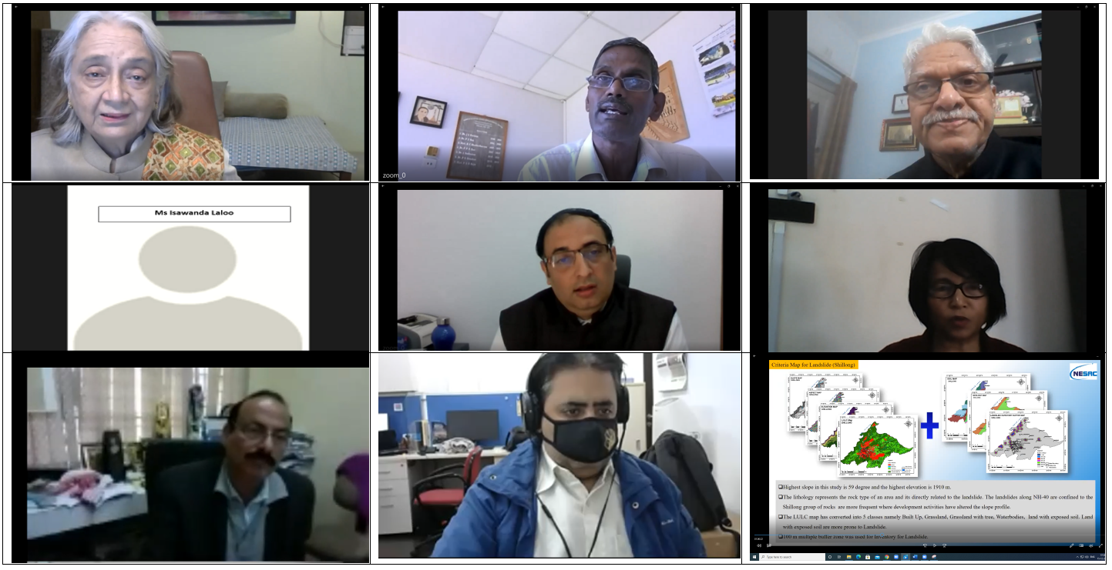
Figure: On-line Panel Discussion (from Left to Right)
1st row: Prof. Jyoti Parikh, Executive Director, IRADe, Dr P L N Raju, Director, NESAC, Prof. Ajit Tyagi, Senior Advisor, IRADe,
2nd row: Ms Isawanda Laloo, IAS, Deputy Commissioner(SMC), Mr Rohit Magotra, Deputy Director, IRADe, Smt. I Mawlong, Executive Director, MSDMA
3rd row: Prof. Devesh Walia, Professor, NEHU, Dr. Mohit Kumar, Research Analyst, IRADe

Annexure

Annexure 1: Workshop Agenda
Agenda
Stakeholders’ Workshop
on
Developing Disaster Resilience Action Plan for Shillong
Date: 15th December 2020

Time | Session Details
10:30 AM – 11:00 AM | Inaugural Session
Welcome Remarks | Prof. Jyoti Parikh, Executive Director,  Integrated Research and Action for Development (IRADe)
Opening Remarks | Prof. Ajit Tyagi, Senior Advisor, IRADe
Special Remarks | Dr P L N Raju, Director, North Eastern Space Applications Centre (NESAC)
Address by the Chief Guest | Kum. Isawanda Laloo, IAS  Deputy Commissioner, East Khasi Hills District, Shillong
Address by Special Guest | Smt. I Mawlong, Executive Director,  Meghalaya State Disaster Management Authority (MSDMA)
Vote of Thanks | Mr Rohit Magotra, Deputy Director, IRADe
11:00 AM – 12:00 PM | Session on Disaster Resilience Action Plan: Methodology & Project Outputs
Disaster Resilience Action Plan: Key Features | Mr Rohit Magotra, Deputy Director, IRADe  Ms. Moumita Shaw, Senior Research Associate, IRADe
Hazard and Risk Mapping of Shillong Urban Agglomeration | Shri Santanu Das, Scientist/Engineer ‘SD’, NESAC  Smt. Nikita Lahiri, SRF, NESAC
Impact of Urbanization on Shillong Urban Agglomeration | Ms Archana Sharma, Project Fellow, GBPNIHESD-SRC
Questions and Answers
12:00 PM – 12:30 PM | Panel Discussion
Panel Discussion | Moderated by: Prof. Ajit Tyagi, Senior Advisor, IRADe  Mr D. P. Dangwal, Suptdg. Geologist, GSI-NER, Shillong  Mr Jayanta Kumar Naik, Director, GSI-NER (Tbc)  Prof. Devesh Walia, Professor, NEHU  Dr A C Lyngdoh, Scientist ‘E’, IMD-Shillong (Tbc)  Dr Saurabh Baruah, Chief Scientist, CSIR Northeast Institute of Science and Technology, Jorhat, Assam
Conclusion & Way Forward | Mr Rohit Magotra, Deputy Director, IRADe

Annexure 2: List of Participants
S.No. | Name | Organization | Job Title
1 | Prof. Jyoti Parikh | Integrated Research and Action for Development (IRADe) | Executive Director
2 | Prof. Ajit Tyagi | Integrated Research and Action for Development (IRADe) | Senior Advisor, IRADe
3 | Ms. Isawanda Laloo | Meghalaya State Disaster Management Authority (MSDMA) | Deputy Commissioner
4 | Ms. Ananya Bhatia | Integrated Research and Action for Development (IRADe) | Research Associate
5 | Shri Santanu Das | North-Eastern Hill University, Shillong (NESAC) | Scientist/Engineer ‘SD’
6 | Dr. Mayank Joshi | G.B. Pant National Institute of Himalayan Environment | Scientist
7 | Dr. Saurabh Baruah | CSIR Northeast Institute of Science and Technology, Jorhat, Assam | Chief Scientist
8 | Smt. I. Mawlong | Meghalaya State Disaster Management Authority | Executive Director
9 | Dr. P.L.N. Raju | North-Eastern Hill University, Shillong (NESAC) | Director
10 | Ms. Nikita Lahiri | North-Eastern Hill University, Shillong (NESAC) | SRF
11 | Prof. Devesh Walia | North-Eastern Hill University, Shillong (NEHU) | Professor
12 | Ms. Moumita Shaw | Integrated Research and Action for Development (IRADe) | Research Analyst
13 | Mr. D.P. Dangwal | GSI-NER, Shillong | Geologist
14 | Mr. Rohit Magotra | Integrated Research and Action for Development (IRADe) | Deputy Director
15 | Ms. Archana Sharma | G.B. Pant National Institute of Himalayan Environment | RESEARCHER
16 | Dr. Diganta Barman | North-Eastern Hill University, Shillong (NESAC) | Scientist/Engineer ‘SF’
17 | Dr. Mohit Kumar | Integrated Research and Action for Development (IRADe) | Research Analyst
18 | Dr. Rajesh Joshi | G.B. Pant National Institute of Himalayan Environment | Centre Head
19 | Altaf Laskar | Assam University Silchar | Student
20 | Barsha Gurung | Urban Development Department, Government of Sikkim | Town Planner
21 | Sriman Rajoo | Stock Dabbler | Self-employed
22 | Dr Robert R. Marak | Health Department | Nodal Officer O/o District Medical Officer
23 | Kumar Abhishek | Integrated Research and Action for Development (IRADe) | Research Associate
24 | Biswajit Chowdhury | Self employed | Self
25 | Dinesh Dhakal | Sikkim State Disaster Management Authority (SSDMA) | Asst. Urban Planner
26 | Dr. Yvette Phira | Directorate of Health Services, Meghalaya | Jt. Director of Health Services (MI)
27 | Debojit Koch | District Disaster Management Authority | District Disaster Management Officer
28 | Pynbianglin Lyngba | District Disaster Management Authority | District Disaster Management Officer
29 | Sachin Wadhwa | Bluent | Partner
30 | Dr Nagaraja Ravoori | National Institute of Rural Development and Panchayat Raj | Geospatial hair Prof
31 | Darimi Lyngdoh | District Disaster Management Authority (Revenue & Disaster Management) Government of Meghalaya | District Disaster Management Officer, East Jaintia Hills District
32 | Bayarilin Shanpru | Royal College of Paediatrics and Child Health | Senior Medical and Health officer
33 | Jonathan Mawthoh | District Disaster Management Authority | District Disaster Management Officer
34 | Sandeep Pathak | Integrated Research and Action for Development (IRADe) | Sr. Consultant
35 | Pipson Marak | District Disaster Management Authority | District Disaster Management Officer
36 | Dr. Iainehskhem Lyngdoh | Ganesh Das MCH Hospital, Govt. of Meghalaya | Paediatrician
37 | Netharius Laloo | Health and Family Welfare, Government of Meghalaya | Doctor
38 | Sudarshan Mathummal | Retired | Scientist
39 | Ebormi S Langshiang | Revenue and Disaster Management Department Govt of Meghalaya | District Disaster Management Officer
40 | Yashi Sharma | Integrated Research and Action for Development (IRADe) | Research Associate
41 | Nangsan Kupar L Khongwir | Government Sector | Soil Officer

About the Project
Developing Disaster Resilience Action plan through GIS and prioritising actions for Natural Disaster Risk Reduction in Urban Agglomerations of Shillong & Gangtok is supported by National Mission on Himalayan Studies (NMHS), under Ministry of Environment, Forest and Climate Change Government of India (MoEFCC, GoI).

The project aims to develop Disaster Resilience Action Plans for Shillong and Gangtok cities; with objectives to develop ward level maps at the scale of 1:4000 and to map the hazard/disaster wise vulnerable zones of the Shillong and Gangtok urban agglomerations while identifying and mapping critical infrastructure at risk through ground surveys. This will assist in developing the Disaster Resilience Action Plan for the identified cities and prioritize actions for Disaster Risk Reduction in the Indian Himalayan Regions (IHR)

About CoE
As a Centre of Excellence, IRADe is furthering the agenda of integrating various urban development efforts and documenting best practices and policy level prescriptions that could be understood and adopted by state and national level decision-makers; local administrations to help them link climate issues with the existing programmes in urban development. The project findings, results, methodology, cities covered and future strategy for India’s Urban Climate Resilience has been delivered to various forums like IPCC-SREX, European Union and others. For more details, check www.climateandcities.org

About IRADe
IRADe is an independent advanced research institute that aims to conduct research and policy analysis to engage stakeholders such as government, non-governmental organizations, corporations, academic and financial institutions. Energy, Climate Change, Urban Development, Poverty, Gender Equity, Agriculture and Food Security are some of the challenges faced in the 21st century. Therefore, IRADe research covers these, as well as policies that affect them. IRADe’s focus is effective action through multidisciplinary and multi-stakeholder research to arrive at implementable solutions for sustainable development and policy research that accounts for the effective governance of techno-economic and socio-cultural issues. For more details, check www.irade.org.

Contact Us

Integrated Research and Action for Development (IRADe)
C-80 Shivalik, Malviya Nagar, New Delhi - 110017
Tel.: 91 (11) 2667 6180, 2667 6181, 2668 2226
Email ID: info@irade.org
@IRADeNewDelhi | @IRADe_Delhi | Web: www.irade.org

Disaster Management in India, Ministry of Home Affairs, GoI, EM-DAT: The OFDA/CRED International Disaster Database
https://www.thehindubusinessline.com/opinion/india-is-not-prepared-for-natural-disasters/article30463153.ece
https://economictimes.indiatimes.com/news/environment/global-warming/india-ranks-5th-in-global-climate-risk-index/articleshow/72367505.cms?utm_source=contentofinterest&utm_medium=text&utm_campaign=cppst
http://gbpihedenvis.nic.in/indian_him_reg.htm
https://www.hindustantimes.com/india/himalayan-region-recipe-for-disaster/story-CO2BLfaLMRQNumz5LeUIqJ.html

